**DAILY ONLINE ACTIVITIES SUMMARY**

|  |  |  |  |  |  |  |  |
| --- | --- | --- | --- | --- | --- | --- | --- |
| **Date:** | **12/06/2020** | | | | **Name:** | **Anusha. K** | |
| **Sem & Sec** | **4th SEM 'A' Section** | | | | **USN:** | **4AL18CS009** | |
| **Online Test Summary** | | | | | | | |
| **Subject** | | **Aadalitha kannada** | | | | | |
| **Max. Marks** | | **24** | | **Score** | | **14** | |
| **Certification Course Summary** | | | | | | | |
| **Course** | **Introduction to information security** | | | | | | |
| **Certificate Provider** | | | **greatlearning academy** | **Duration** | | | **5 hours** |
| **Coding Challenges** | | | | | | | |
| **Problem statement: Given two positive integer start and end. The task is to write a Python program to print all Prime numbers in an Interval.** | | | | | | | |
| **Status: completed** | | | | | | | |
| **Uploaded the report in Github** | | | | **yes** | | | |
| **If yes Repository name** | | | | [**https://github.com/anusha20219/Lockdown-coding**](https://github.com/anusha20219/Lockdown-coding) | | | |
| **Uploaded the report in slack** | | | | **yes** | | | |

ONLINE TEST DETAILS: Aadalitha kannada test was conducted from 11.30 am to 11.55 am. There were 25 questions and were mcq type .

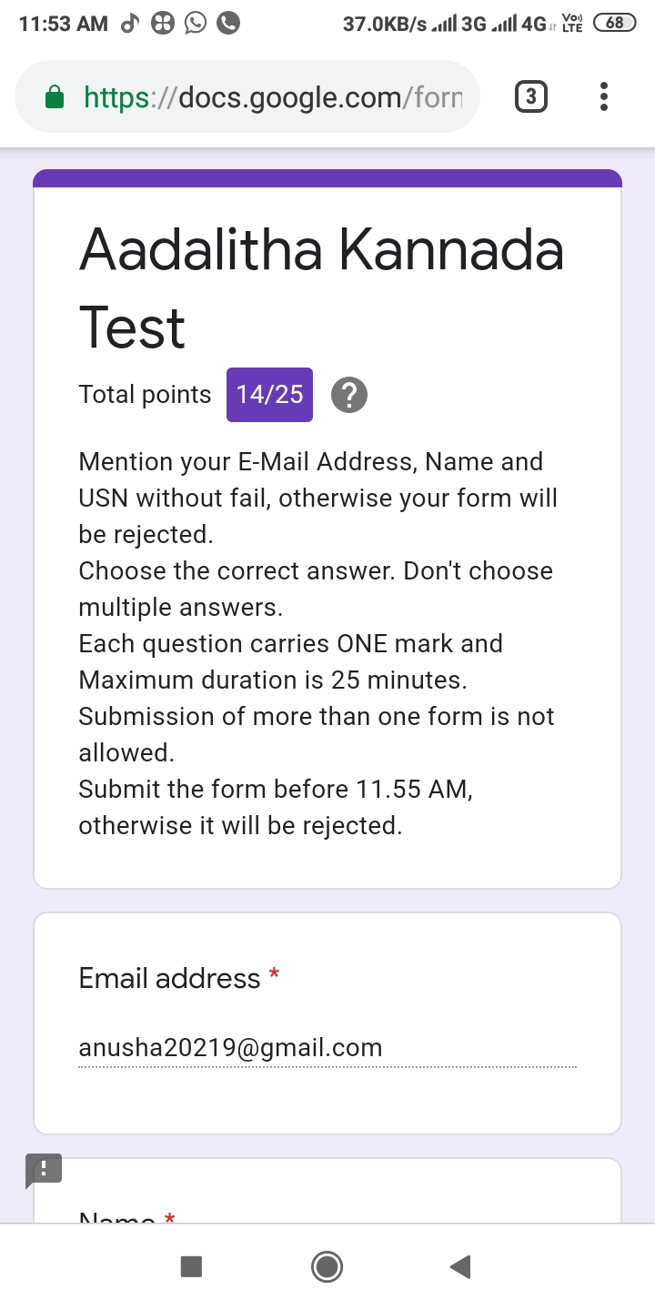

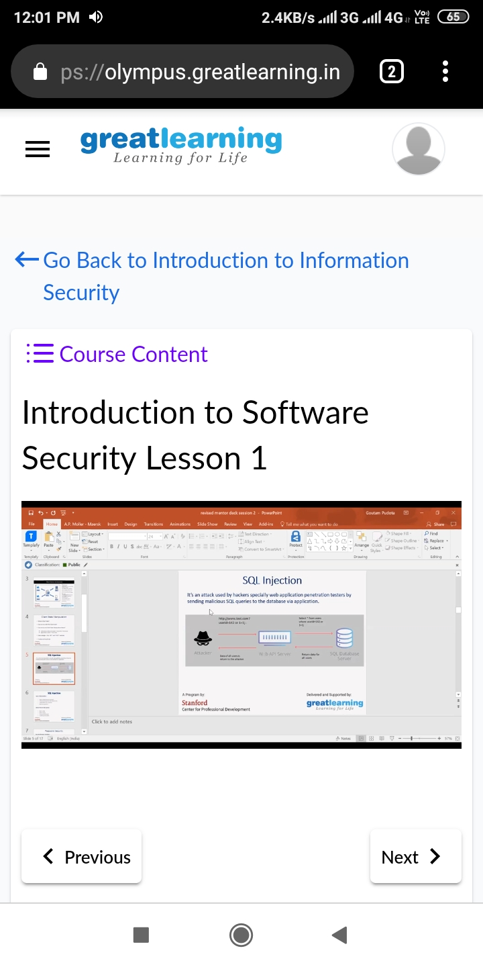CERTIFICATION COURSE DETAILS: Today I started with introduction to software security certification course. I studied about the future of cryptography and two lessons of introduction to software security.

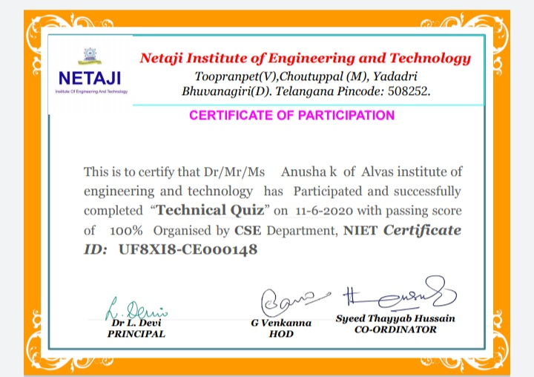

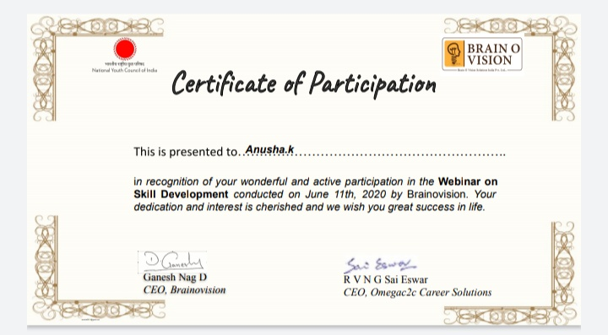

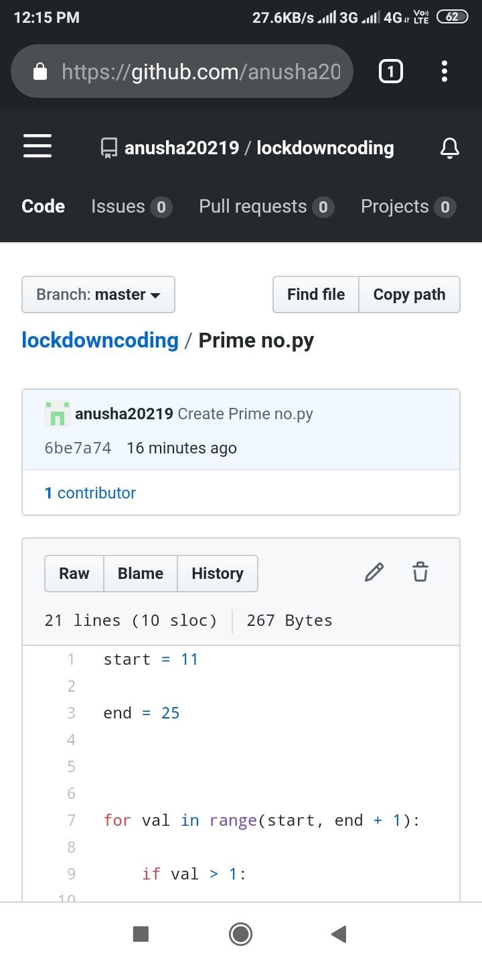Coding challenge details:Problem statement:Given two positive integer start and end. The task is to write a Python program to print all Prime numbers in an Interval.